**User manual**

v.2018.04.eng

Table of contents

1. General information 4

2. Sign in 6

3. General controls 7

3.1 Top control panel 7

3.2 Messenger 7

4. Newscasts main page 8

4.1 Programs, newscasts, copyboxes, and templates menu 9

4.1.1 Choose programs, add new newscasts 10

4.1.2 Newscast release schedule 11

4.1.3 Copybox 12

4.1.4 Templates 13

4.2 'Edit newscast' (folder, copybox, template, or newscast) window 14

4.3 Main window 15

4.3.1 Newscast info 16

4.3.2 Newscast content — items list 17

4.3.3 Item 18

4.4 Incoming news feed 21

5. 'Edit item' dialog window 22

5.1 Top control panel 23

5.2 Right media files control panel 24

5.3 Editor box 25

5.3.1 Top panel 25

5.3.2 Script text editor area 26

5.4 Social networks 33

6. Working with videos from newscast schedule 35

6.1 Item videos dialog 36

6.2 Captions dialog 37

7. Scripts 39

7.1 View and print script dialog 40

8. Archive 41

9. Incoming news feed 43

10. Statistics 44

11. Settings 46

11.1 SOT templates 47

11.2 Current user settings (Administrator in this instance) 49

11.3 Social networks 50

11.4 RSS feed 51

11.5 Deleted Items 52

11.6 Programs 53

11.7 User roles 54

11.8 Users 57

11.9 Item types 59

11.10 Scripts templates 60

# General information

|  |  |
| --- | --- |
| May24 client is a web-based interface available through Internet browsers. | ***It's important*** *to understand that you sign in as one of many users in a system meant for collaborative work. Other users may work simultaneously with you (using their own devices).*  *Your client interface enables access to shared data situated on one central computer — the May24 server. No changes you make are stored on your device; instead, you introduce changes to data stored on the server, i.e. in one place.*  *Any change you make is instantly shown on each client device which is currently signed in.* |
| **The system has:**  **Item** Main working unit Items comprise a newscast. There are several types. Each item can have multiple types of data.  **News** Items can be grouped into stories, or news. For example, a simple group can be 'intro + news'.  **Newscast** Multiple items that make up a specific newscast.  **Program** Your administrator sets up a list of programs according to your company's production schedule, e.g. 'news', 'Sunday analytics', 'morning' etc.  **Newscast** Each program has its own newscast schedule.  **release**  **schedule**  **Media files** Media files can be attached to any item. Files can have any format or type — video, photo, PDF etc. However, the main use of this tool is to attach videos. You can attach multiple video files, e.g. 'source video', 'final edit'. One of the video files is set up as the 'main file'. It opens in the player by default and then goes to the playout (airs). | *Besides programs and release schedules, the system has a few more things to offer:*  **Copybox** Used to store drafts, items with no newscast attached yet, etc.  **Templates** A place for storing special edits of newscasts, news, and individual items meant for reuse. There is no need to create each newscast from scratch. When you have a set structure, you can put it into a template and use it for each new newscast, e.g. you can take previously made graphic items and just insert them into the video you are currently editing when and where needed.  **Archive** A place for newscasts that have aired and should be archived. You can search texts, dates, and authors in archived materials. Any archived newscast can be restored and brought back into your release schedule.  **Incoming** This section is enabled if your administrator set up RSS  **news feed**  feeds for incoming news feeds. You can use keyword filters.  **Messenger** Use it to send messages to other users in the system. |
| **User rights and roles:**  Our software has a flexible user rights system using 'roles'. Your administrator can assign 'roles' to users with various access levels to programs, schedules, archive etc.  A 'role' is a set of 'rights' in a specific program. User rights may be set to read-only, editing only one's own items, editing or deleting anyone's items etc.  Same user may be the 'chief editor' in the morning program and a simple correspondent in the 'evening news' program. User rights will vary, too. | **Activity log:**  Each user action that modifies or deletes data is logged.  **Recycle bin:**  When you delete a newscast or an item, it is moved to the recycle bin, and any user with appropriate access level can restore it. |

# Sign in

|  |  |  |
| --- | --- | --- |
| To access May24, you need to get a link from your administrator. Following the link, you will find the sign-up page. | **User**  **Password**  **Login** | the list of users This list only contains users created by the administrator in advance.  user password The system only recognizes passwords  created for users in advance in the administration module.  when you press this button, the system checks whether the user-password combination is right and then opens the main page. |

*On the main page, you may see the release schedule for the program set as 'default'. Your administrator may change this setting.*

*When the main page loads, the system will ask you to choose a newscast from the release schedule to show.*

# General controls

## Top control panel



|  |  |  |
| --- | --- | --- |
| **Newscasts** 'Release schedule' main screen |  | **Eng** Language |
| **Archive** Upload and search archived materials |  | **Help** Open this manual |
| **News feeds** Search incoming news |  | **Exit** Sign out of May24 |
| **Statistics** Statistics filter page |  |  |
| **Settings** System administration page |  |  |

## Messenger

You will find a messenger window in the bottom-right corner of the page.

|  |  |
| --- | --- |
|  | The window is maximized when you click it. Double click minimizes it. |
|  | The messenger shows the full user list. All users must be introduced to the system by the administrator.  Online users are highlighted with green color.  Offline users will get incoming messages once they log in. |

# Newscasts main page

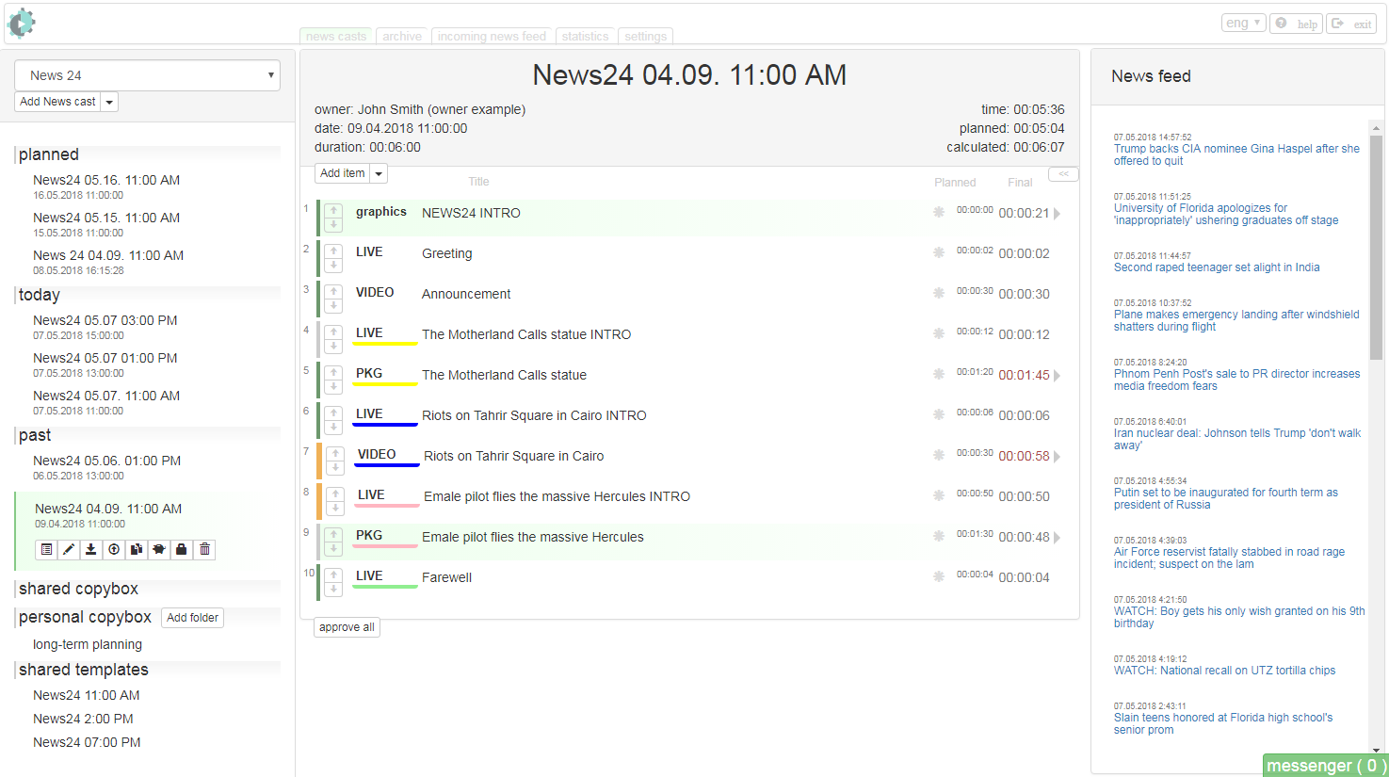

## Programs, newscasts, copyboxes, and templates menu

|  |  |
| --- | --- |
|  | **Choose programs, add new newscasts**  **Newscasts schedule**  **Copyboxes**  **Templates** |

### Choose programs, add new newscasts

|  |  |  |
| --- | --- | --- |
|  | **Program**  **The list  of programs**  **Add newscast** | A vital part of the system. The administrator puts in the full list of programs produced in your company and assigns roles in those programs to users.  This list will only include programs available to current user. When you choose a program, the main page will load its newscast release schedule.  This button adds a newscast to the release schedule by default. It opens the 'Edit newscast' page.  Clicking the dropdown list will allow you to use a template to create a newscast. At least one template should be created beforehand. See 'Templates' chapter to find more. |

### Newscast release schedule

|  |  |  |
| --- | --- | --- |
| **Planned. Today. Past.** Newscast grouping is done automatically according to their release date.    When you choose a newscast, the main page will show its content and an action panel. |  | **Script** opens an additional window with the text for the newscast. See 'Scripts' chapter for more on how to work with them. |
|  | **Edit** newscast info. E. g. name, timing, date, time. See 'Newscast info' chapter for more. |
|  | **Save to RTF** — save the newscast in an RTF file**.** |
|  | **Copy from another newscast** — this link opens a window to choose and insert items from other newscasts. Chosen items are copied into current newscast. |
|  | **To templates** — create a template from this newscast. See 'Templates' chapter to find more. |
|  | **To copybox** — move the newscast to the copybox. See 'Copybox' for details on how to work with it. |
|  | **To archive'** — move current newscast to the archive. See ­­'Archive' chapter for details on how to work with it. |
|  | **Delete** — moves current newscast to the recycle bin and removes it from the release schedule. It can be restored later though, see 'Restoring deleted data' for more. |

### Copybox

|  |  |  |
| --- | --- | --- |
| Used to store drafts, items with no newscast attached yet, etc.    Click a folder, and its contents will load to the main page together with the action panel. |  | **Shared copybox** — a copybox available to every user with access to current program. You can only move items to this copybox from newscasts or your personal copybox.  **Personal copybox** — your personal copybox, unavailable to other users.  **Add folder** — open a dialog window to add a personal folder. |
|  | **Edit** — open folder info editing dialog window. |
|  | **Move to newscast** — move the whole folder into the newscast release schedule. |
|  | **Delete** — move the folder into the recycle bin and remove it from the release schedule. The folder can be restored, see 'Restoring deleted data' for more. |

### Templates

|  |  |  |
| --- | --- | --- |
| Store your newscast templates here. To create a template, add a newscast to the release schedule, fill it with some content, and then move it to the templates.    Clicking the template will open it in the main frame and bring up its action panel. |  |  |
|  | **Edit** — open template info editing window. |
|  | **Move to newscasts** — create a newscast from the template and add it to the release schedule. |
|  | **Delete** — move the template to the recycle bin and remove it from the release schedule. The template can be restored, see 'Restoring deleted data' for more. |

## 'Edit newscast' (folder, copybox, template, or newscast) window

Clicking **'Add newscast'** (see 1.2.1) or **'Edit'** (see 1.2.2, 1.2.3, 1.2.4) opens **'Edit newscast'** window.

|  |  |
| --- | --- |
| **Name**  **Owner**  **Date**  **Duration**  **Chrono**  **Planned**  **Calculated**  **Carrier**  **Save**  **Close** | The name of the newscast.  Choose a user to assign them production editor rights.  Date and time for newscast airing  (or readiness deadline)  Newscast duration.  Total duration of all the items in a newscast. Read only.  Planned total duration of all items in the newscast. Read only.  Сalculated total duration of all items in the newscast. Read only.  Path to the release media file and timecode. Filled if needed before archiving the newscast.  Click to save data.  Click to close the dialog window. |

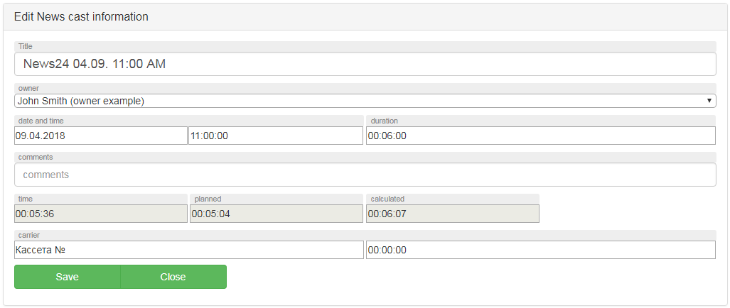

## Main window

Shows info on current newscast from the release schedule, one of the copybox folders, or template.

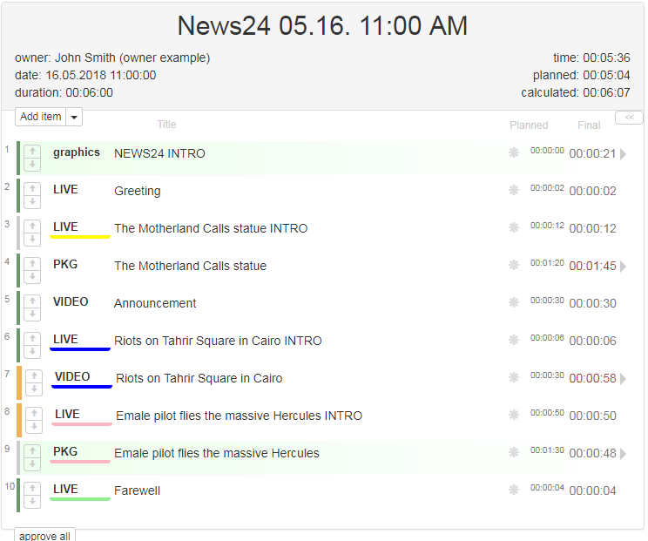

### Newscast info

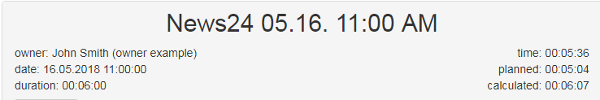

**Newscast name**

**Owner** Shows the user with production editor rights for current newscast.

**Date** Date and time for newscast airing (or readiness deadline).

**Duration** Newscast duration.

**Time** Total duration of all the items in a newscast. Read only.

**Planned** Planned total duration of all items in the newscast. Read only.

**Calculated** Сalculated total duration of all items in the newscast. Read only.

### Newscast content — items list

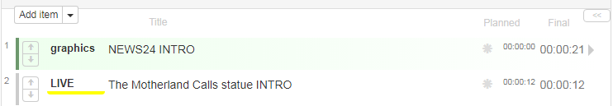

|  |  |  |
| --- | --- | --- |
| **Add item** — add an item to the list. Use the drop-down list to choose a specific type of items.    **Approve all** — changes the status of all items in the newscast to 'ready' and 'approved'.  **'Full screen schedule'** Maximizes the list of items. |  | Order number. Click to change. When you close the editing window, the item will move to the new position in the list. |
|  | Color indicator — shows an item's readiness level. Gray: Item 'not ready' and 'not approved', Yellow: Item marked as 'ready' by the author, but not approved by the production. Green: Item 'ready' and 'approved'. |
|  | Move the item up or down in the list. |
|  | Color underlining for items. Shows item type. Clicking changes color. Color is used to group items in a piece of news. See 'Edit item' for more about item types. |
|  | Item name. Clicking opens 'Edit item' window. |
| 🞿 | Edit the item's name without bringing up the 'Edit item' window. |
|  | Planned and calculated duration. |

### Item

Item is maximized when you click its name (see 'The Motherland Calls statue' on the picture).

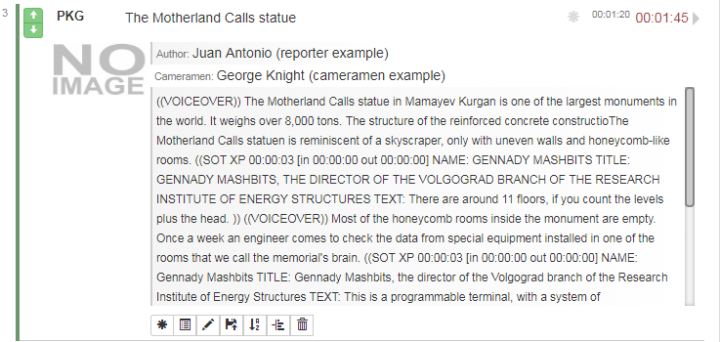

Then you see a screenshot of the main media file attached to the item, item text, and names of the author and operators.

Clicking the screenshot opens the media file dialog window (see 'Media file dialog' chapter).

Click the name again to minimize the item ('The Motherland Calls statue' on the picture).

#### Item actions.

Use the action bar to interact with the item. 

|  |  |
| --- | --- |
| 🞿 | InLine Edit — opens the item in the newscast's item list for editing. Editing functionality is limited in this view. For full functionality, open the 'Edit item' window. |
|  | Script — opens a window to see the script (see 'Script view window' for more). |
|  | Edit — opens the 'Edit item' window. |
|  | Add file — attach a new media file to the item. This function is also available in the 'Edit item' window. |
|  | Append item — adds a new item to the newscast's item list after the current one and opens the new item for editing. |
|  | EDL (Editing Decision List) — export media file markup (if it is created by the user in the 'Edit item' window) to an XML file for further use on an editing workstation. |
|  | Delete — moves the item to the recycle bin. |

#### InLine Edit.

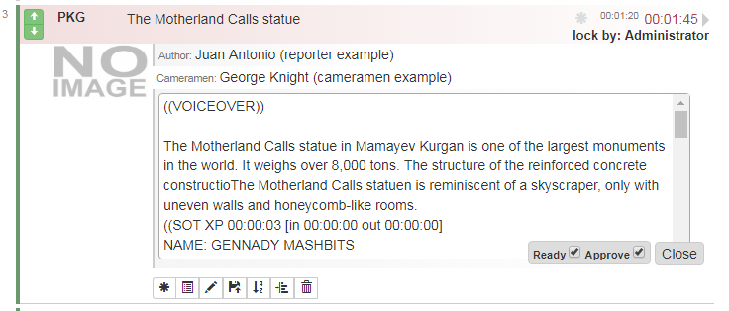

You can edit texts and readiness flags for the item in-line. Item is locked while you edit it. Other users will see red highlighting, which means the item is now blocked for editing by user X. Same lock mechanism is triggered if the full 'Edit item' window is open (see 'Edit item' chapter).

## Incoming news feed

|  |  |
| --- | --- |
|  | **Newscast name**  Incoming news feed. Created from your RSS subscriptions.  Your administrator can add feeds on the 'Settings' screen.  You can drag an incoming news item to the items list to create a new item on its basis. |

# 'Edit item' dialog window

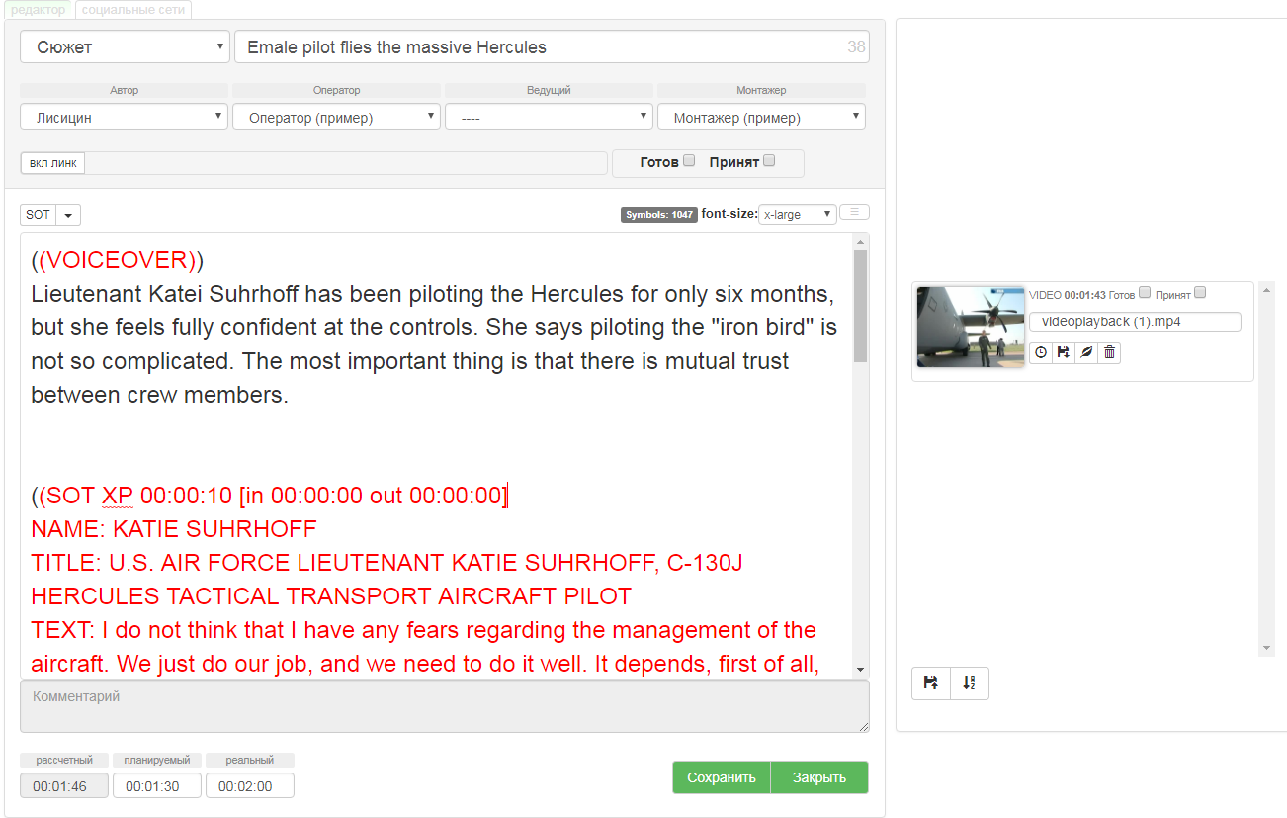

**Control elements.**

## Top control panel



|  |  |
| --- | --- |
|  | **'Editor box' bookmark.** Opens item editing page. |
|  | **'Social networks' bookmark.** Opens social networks sharing page. |

## Right media files control panel

|  |  |  |
| --- | --- | --- |
| Shows a list of uploaded media files attached to the item. |  | Duration |
|  | Readiness flags. With both flags checked, the video becomes the main material and goes straight to the playout. |
|  | File name |
|  | Insert media file's timing into the item. Mostly used with the final edition of the video. Updates the item's timing and total chrono of the newscast. |
|  | Download file. Downloads the video file into specified folder. The file is in LRV format (proxy copy). |
|  | Insert video info into item's script text.  Inserts timecode and file marker to item script text (at cursor position). |
|  | Delete |
|  | Upload a media file and attach to the item. Main action for manual ingestion. You can add new video files to the item this way. After attaching a file the system automatically converts the video into HRV and LRV formats. You will see the LRV (proxy copy) in the interface. |
|  | File list sorting. |

## Editor box

### Top panel

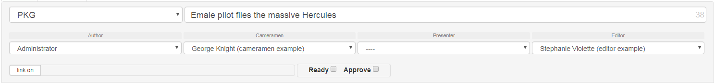

|  |
| --- |
| **Item type −** By default the system will have following item types:   * Graphics – shows the item's design elements in the structure, e.g. intro, outro, cut-ins. * Live – shows studio items with the presenter on-screen. * Video – shows studio presenter's voiceover text. On-set video, studio sound. * PKG – video and sound come from the set.   You can set your own item types in settings. Also sets which items' texts will go to the teleprompter. |
| **Item name** − Name shown in newscasts lists and playlists. The number at the end of the field shows symbols count for the name. |
| **Author** −An important field which allows authors to check materials planned assigned specifically to them. Final chrono is automatically calculated using given text length and presenter's reading speed. When no presenter is set, the system uses reading speed for 'Author'. |
| **Cameramen** − Usually left empty for studio items. Also used to search in the archive and calculate working time. |
| **Presenter** −Set for items with presenters. Final chrono is automatically calculated using given text length and presenter's reading speed. When no presenter is set, the system uses reading speed for 'Author'. |
| **Editor** –Set for items with edited videos. If you set a particular editor during planning, they will receive an editing task. |
| **Link on** –Get a one-time external text link to the item. Useful when you need to get an approval from someone not registered in MAY24. You can set an expiry date for the link**.** |
| **Ready & Аpprove** −item's readiness flags. Ready flag is checked by the author when the text is ready. Аpprove flag is checked by the production editor. The item is highlighted yellow or green in the item list correspondingly. |

### Script text editor area

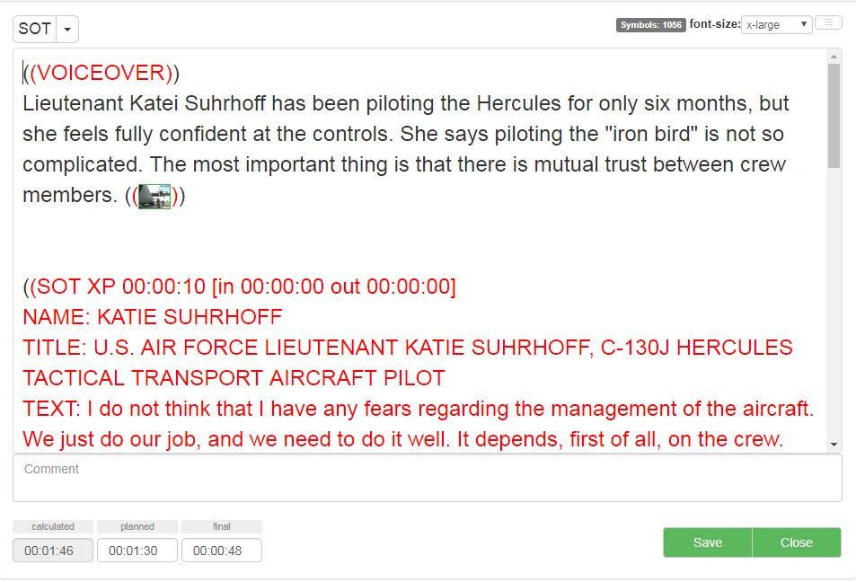

|  |  |
| --- | --- |
|  | Insert special text blocks and markup into the item text. See below for more. |
|  | Item text symbol count. |
|  | Change item text font size for your convenience. |
|  | Change history. See below. |
|  | Comments. Used by both production editor and item author as a memo field for item text. |
|  | Calculated time. Read-only field. Calculated using item text and authors'/presenter's reading speed (when set). Summed up with SOT and intervoice times (if item text has SOT and/or intervoice blocks). |
|  | Planned time. Usually set for each item in the newscast during planning stage. You can allocate total newscast time among items and set time limits for authors within their tasks. |
|  | Final time. Depending on item type you can set it manually for the presenter's script or using a video item's duration. There is a timer below that shows reading time for each item and calculated chrono. See below. |
|  | Save – save changes. Close – save changes and close editor. |

#### Insert special text blocks and markup into item text.

**SOT dialog**

|  |  |
| --- | --- |
|  | **SOT** (Sound on tape) − Clicking SOT opens SOT insert dialog window. |
|  | **Chrono** – shows chrono.  **Mark IN, Mark OUT** – shows when SOT start and finish timecode is known in the video.  **Name** – speaker name.  **Title** – job title or other info about the speaker.  *These fields can later be used for your captioning system, during editing or on air.*  Then goes the sync text. |
|  | SOT is inserted after you fill the fields and press 'Add SOT'. |

**Insert SOT from templates (how to set up templates − see part 11.1)**

|  |  |
| --- | --- |
|  | Type in the initials of the person you need into the drop-down list below. If the person's name has been previously entered in the settings, it will show automatically.  It's useful when working with popular newsmakers and their syncs. |

**Markup**

|  |  |
| --- | --- |
|  | Same drop-down list allows you to choose other text blocks for internal use. Admin can add markup elements that your editorial uses to the drop-down list.  All markup and comments in the item text have double brackets around them. This text doesn't count towards item calculated time nor does it go to the teleprompter (in case the item has a presenter set and is meant for the teleprompter).  **TITLE:** inserts title. Later titles can be used in the title workstation.  **Nat SOT:** set natural sound tag and its chrono.  **COMMENT:** insert a comment (this text not calculated in total chrono nor sent to the teleprompter).  **(( SHOT ))** and others: any other internal markup or comments set up by your admin in the settings tab. |

**Reading speed timer**

|  |  |
| --- | --- |
|  | There are several options for setting item final time.  When you set up reading speed for the block's author or presenter, the whole text is read with this particular person's speed.  When you know the duration of the video attached to the final version of the item, you can just copy it into 'final time' using video control panel.  Pressing 'final' launches a timer (it blinks red). Then the author or the presenter can read the text and press the button again to stop the timer. Recorded time will be saved as final time.  This action only applies to current item and doesn't affect default reading speed in your settings. |

#### Working with source video and item text. Creating EDLs − Editing Decision Lists.

|  |  |
| --- | --- |
| You can watch source video and enter timecodes for certain parts into the item text. When you finish editing item text, you can get your EDL in the newscast list to send to the cutter. | |
|  | 1. Place the cursor where you need to paste. 2. You can paste timecodes for the whole file or...   View file.   1. Click the initial timecode to fix mark-in. 2. Offset start of the video is shown red on the timeline. 3. Click the final timecode to set mark-out. 4. Offset end of the video is shown in yellow. Player cycles only selected fragment. 5. Clicking the timecode pastes mark-in and mark-out into the text.   Clicking the thumbnail in the text plays the fragment. |
|  | 1. When you exit the editor and see the playlist, you can download EDL by clicking a button. |

## Social networks

|  |  |
| --- | --- |
|  | 1. Insert the media file you want as a picture for your item. 2. Thumbnail. 3. Title (item title is used by default). 4. Lead. 5. Publication text Item text is shown by default. 6. Publication platforms list (see below). |

#### Editing publication platforms list. Publishing.

You can set up a list of platforms in settings. Your admin can do that when setting up the system.

A user can send their ready items to any or all platforms.

Separate platform-dependent versions are available.

You can also publish edited versions of the same item on the same platform again.

You can see a full list of publications for each platform.

|  |  |
| --- | --- |
|  | Platform name, publish button, number of publications |
|  | Clicking publish button brings up a confirmation dialog. |
|  | Publication counter increases after confirmation. Yellow highlight means that publishing task has been received by the system. Green means publication was successful. |

# Working with videos from newscast schedule

|  |  |
| --- | --- |
|  | You will see a screenshot for items with media in the schedule. You don't need to open the editor to work with them. Clicking the thumbnail opens a dialog window. |

## Item videos dialog

|  |  |  |
| --- | --- | --- |
|  |  | Readiness flags  NB! Item flags and video flags are separate. Each one is set up individually. |
|  | Opens captions dialog (see below for more) |
|  | Download video  Downloads proxy copy of the video into specified folder. |
|  | Delete video |
| You will see a list of all videos attached to the item below the player. | |

## Captions dialog

button in the previous dialog brings up caption dialog

|  |  |  |
| --- | --- | --- |
| Hotkeys: Ctrl+Space – play/stop, Enter — paste timecode and text into the list. The system takes initial timecode for the fragment from the player. |  | Layers list |
|  | Caption pop up timecode |
|  | Caption text |
|  | Time shift for all captions Use when you need to shift all captions appearance time |
| 🞧 | Add caption to the list |
|  | Export a text file with captions |
|  | Caption lines |
| You will see item text below the player. You can use it to copy item text and paste it into the captions list. | |

#### Creating captions

You can create the captions list (timecode + caption) in several ways.

Simplest way:

* Stop your player at a certain frame,
* Copy item text and paste it into the text field,
* Press Enter.

If you need to transcript the sound for the captions:

* Stop your player at the beginning of the video.
* Press Ctrl+Space to play and start typing the text you hear.
* Press Ctrl-Space again to stop the player.
* Press Enter. Text and timecode will be automatically pasted into the list.

# Scripts

|  |  |
| --- | --- |
|  | The system allows you to convert the whole newscast or certain items into a text script. You can choose text formatting and info to show using script templates. Script templates are edited in the settings tab.  View scripts:   1. Find 'newscast editing' on the control panel if you need to see the whole newscast script   or   1. Find 'item editing' if you need to see the script for a certain item. |

## View and print script dialog

|  |  |  |
| --- | --- | --- |
|  |  | Script templates list |
|  | Print script |
|  | |

# Archive

|  |  |  |
| --- | --- | --- |
|  |  | Search text |
|  | Date range |
|  | Search author |
|  | Launch search |

#### Archive search results

|  |  |
| --- | --- |
|  | 1. Choose a newscast 2. Open the item you need 3. You can unarchive a newscast and bring it back to current newscast list |

# Incoming news feed

|  |  |  |
| --- | --- | --- |
|  |  | Search text |
|  | Date range |
|  | Source search |
|  | Launch search |

# Statistics

#### Search

|  |  |  |
| --- | --- | --- |
|  |  | Date range selector |
|  | Set – search in the date range, Cancel – deselect range. |

#### Result view

|  |  |  |
| --- | --- | --- |
|  |  | Author filter |
| - | Presenter filter |
|  | Editor filter |
|  | Clicking item type shows a list of newscasts |

# Settings

|  |  |
| --- | --- |
|  | SOT templates – edit sync templates  Current user (Administrator) – settings for the user currently logged in  Social networks – edit publishing platforms  RSS feed – edit news feeds sources  Deleted Items – Recycle Bin  Programs – set up and edit programs  Users roles – create and edit user roles and rights  Users – edit users  Item types – set up item types  Scripts templates – edit script templates |

## SOT templates

|  |  |  |
| --- | --- | --- |
|  |  | New template |
|  | Name of the speaker |
|  | Job title of speaker |
|  | Delete template |

#### SOT templates usage

|  |  |
| --- | --- |
|  | Use SOT templates in the editor. Typing the first letters in the field shows speakers' names. Choose one to insert into SOT. |

## Current user settings (Administrator in this instance)

|  |  |  |
| --- | --- | --- |
|  |  | Current password |
|  | New password |
|  | Repeat new password |
|  | Change password |
|  | Average reading speed (symbols per minute) |
|  | Change reading speed |

## Social networks

|  |  |  |
| --- | --- | --- |
|  |  | Add a publishing platform |
|  | Choose platform |
|  | Internal platform name for the editorial |
|  | Authentication key |
|  | Delete platform |

## RSS feed

|  |  |  |
| --- | --- | --- |
|  |  | Add a news feed |
|  | Source name |
|  | Source URL |
|  | Delete news feed |

## Deleted Items

|  |  |  |
| --- | --- | --- |
|  | Recycle bin  Shows all deleted items with deletion date and username who deleted it | |
|  | Restore item |

## 11.6 Programs

|  |  |  |
| --- | --- | --- |
|  |  | Add a program |
|  | Program name |
|  | Delete program |
|  |  |

NB! Deleting a program deletes all newscasts in it. To restore them, contact MAY24 support.

## 11.7 User roles

The system has some preset roles. You can't change them. Your admin can create any other roles.

|  |  |  |
| --- | --- | --- |
|  |  | New role |
|  | Role name |
|  | Edit role rights |
|  | Use current role as a template for new role |
|  |  | Delete role |

NB! Deleting a role already used in programs removes all rights user had in those programs. To restore their access to newscasts you will need to assign them new roles.

#### Assigning rights

Any role is a set of rights. Each user is given a certain role (a set of rights) in each assigned program. E.g. John can be Chief Editor in News24 program and a Reporter in another program.

Press  to assign role rights. See section 11.8 for user roles assignment.

|  |  |
| --- | --- |
| **right to create Newscasts only where you are Owner** | Users can create newscasts. They will be assigned Newscast Owner role automatically, and no other Owner can be assigned thereafter. |
| **right to edit Newscasts only as Owner** | Users can edit newscasts only if they have Owner rights. |
| **read only access to Newscasts** | Users can only view newscasts. No edit access given. |
| **right to create any Newscasts** | Users can create newscasts and add them to the schedule. |
| **right to edit information about Newscasts only where you are Owner** | Users can edit newscast info only when they have Owner role assigned. |
| **right to delete any Newscasts** | Users can delete newscasts. |
| **right to create Newscasts only as Owner** | Users can create newscasts only under their name |
| **right to delete Newscasts only where you are Owner** | Users can delete only those newscasts where they have Chief Editor rights. |
| **right to be on the list of Chief Editors** | Users with this right can be included into the Chief Editors list. This list is used to assign Chied Editor to programs. |
| **right to be on the list of Owners** | Users with this right can be included into the Production Editors list. This list is used to assign Production Editor to newscasts. |
| **right to change the order of Items** | Change item order in newscasts. |
| **right to create any Items** |  |
| **right to edit any Items** |  |
| **right to delete any Items** |  |
| **right to create Items only where you are Author** | Users can create items and become authors automatically. This doesn't mean they can reassign authors. |
| **right to edit any Items only where you are Author** | Users can only edit items they authored. |
| **right to delete any Items only where you are Author** | Users can delete items where they have Author role. |
| **right to edit items as Presenter** | Users can edit items where they have Presenter role. |
| **right to be on the list of Cameramen** |  |
| **right to be on the list of Presenters** |  |
| **right to be on the list of Authors** |  |
| **right to edit accepted Item** | Users with this right can edit items after they were accepted by the editor. The editor will get a notification that an accepted item is being edited. |
| **right to edit Media** |  |

## 11.8 Users

|  |  |  |
| --- | --- | --- |
|  |  | New user |
|  | User name |
|  | Password |
|  | Edit user info and roles |
|  | Use as a template to create a new user |
|  | Delete user |

NB! Deleting a user does not delete their name in any current or archived newscasts.

#### Edit user info

Clicking Edit button (Demo user in this instance) brings up the following options

|  |  |  |
| --- | --- | --- |
|  |  | Allows a user to become an admin |
|  | Allows a user to use internal IM |
|  | Program list. **+** sign shows that the user has a role in this program. |
|  | Selected program |
|  | Role in selected program. In this instance, Demo user has 'read only' rights and cannot be a cameraman, editor, or presenter. |

## 11.9 Item types

|  |  |  |
| --- | --- | --- |
|  |  | Add new item type |
|  | Item type name |
|  | This flag shows whether current item can have an author. E.g. GRAPHICS items can't have an author. This type is used for design elements. |
|  | This flag shows whether current item can have a cameraman. E.g. LIVE items can have no cameraman assigned if you only specify them for on-set PKG videos. |
|  | This flag shows whether current item can have a presenter. E.g. PKG items don't have a presenter since it's a ready video (news story, report) inside a newscast. |

## 11.10 Scripts templates

|  |  |  |
| --- | --- | --- |
|  |  | New template |
|  | Template name |
|  | Edit template |
|  | Use current template to create a new one |
|  | Delete template |

#### Editing templates. General principles

NB! This section is only available to admins. You will need some HTML experience to work with templates.

Templates are simple HTML (like a web page) with special tags — variables. A template has two sections: newscast and item. Markup is the same.

**Newscast**

|  |  |
| --- | --- |
|  | Left side shows raw HTML script. Right side shows variables for the newscast.  When editing, insert variables into your HTML code where needed to be replaced by current newscast data later when viewing. |

**Item**

|  |  |
| --- | --- |
|  | Left side shows raw HTML script. Right side shows variables for the newscast.  When editing, insert variables into your HTML code where needed to be replaced by current item data later when viewing. |